The Enterprise Mashups
By Dmitri Ilkaev

This paper provides an overview of the Enterprise Mashups concept and underlying technology stack. We show that mashups can exist anywhere on the Web and currently there are 5 the most common styles of the mashups. While the overall concept, especially at the enterprise level is still evolving together with the base technologies and standards, there are multiple product offering available on the market which allow to design and implement robust a scalable Enterprise Web 2.0 applications.

1.0 Introduction

Wikipedia defines Mashup (web application hybrid) as a website or application that seamlessly combines content from more than one source into an integrated experience. Content used in mashups is typically sourced from a third party via a public interface or API, although some in the community believe that only cases where public interfaces are not used count as mashups. Other methods of sourcing content for mashups include Web feeds (e.g. RSS or Atom) and JavaScript. The term "enterprise mashup" has been coined to describe Web applications that combine content from more than one source into an integrated experience, which share many of the characteristics of service-oriented business applications (SOBAs), which are applications composed of services in a declarative manner. There is ongoing debate about "the collision of Web 2.0, mashups, and SOA", with some stating that Web 2.0 applications are a realization of SOA composite and business applications
ZapThink in [1] had introduced enterprise mashups (Web applications that combine content from more than one source into an integrated experience) and discussed their relationship to SOBAs, which are applications composed of Services in a declarative manner. The article also concluded that for mashups to be of interest to the enterprise -- to be an "enterprise mashup," they must incorporate governance so as to prevent unintended or un-allowed consequences of combining Enterprise Services.
Every entrepreneur looks for three key characteristics when searching for the right business opportunity:
- The new approach must meet a current or future business need
- The new approach must be innovative in some important way
- The problem the new approach presents must be hard enough so that solving it provides a barrier to entry to competitors, but not so difficult as to take more time or money than potential investors have the patience to provide.
For a mashup-based solution to be innovative, it follows that it can't be too much like an existing approach. For example, it doesn't make sense to retool a business-process management tool, portal application, or a traditional collaboration tool. Instead, the new solution must break new ground. The key to this innovation, unsurprisingly, is SOA. Without SOA, mashups are relegated to the Web tier of an n-tier architecture, essentially a fun thing to do in a browser with Rich Internet Application (RIA) capabilities leveraging technologies like Asynchronous JavaScript and XML (AJAX) and Flash.
Mashups use almost remkarably simple, basic techniques for connecting things together. This includes guerilla-style development techniques that deliver results in preference to formal, upfront engineering. This might mean using Javascript includes of another site’s software, straightforward Web services and feeds based directly on top of HTTP, and JSON for data retrieval and remixing. And with initiatives like OpenAjax, we might get first real conventions for component interoperability in the browser. See below mashups technology layers presented in [2].

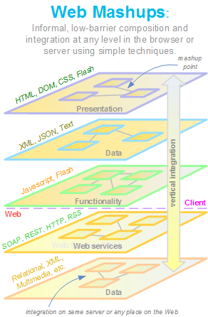
Figure 1. Mashup technology layers
This leads us to a key definitional point. Are mashups purely browser-based or are they fundamentally Web-based and could reside as easily in a Web browser or Web server?
Dion Hinchcliffe in [2] says that mashups can exist anywhere on the Web, either primarily on the server or entirely on the client side. Mashups provide a mindset of informal techniques that just work by virtual of the concept of "small pieces, loosely joined". Accepting that information, visuals, and software can be remixed and combined at multiple levels in an application stack means that there are (at least) five places that mashups can take place. These five styles are:
- Presentation Mashup: This is the shallowest form of mashup in the sense that underlying data and functionality don’t meet. Information and laout is retrieved and either remix or just placed next to each other. Many of the Ajax desktops today fall into this category and so do portals and other presentation mashup techniques.
- Client-Side Data Mashup: A slight deeper form of mashup is the data mashup which takes information from remote Web services, feeds, or even just plain HTML and combines it with data from another source. New information that didn’t exist before can result such as when addresses are geocoded and display on a map to create a visualization that could exist without the underlying combination of data.
- Client-Side Software Mashup: This is where code is integrated in the browser to result in a distinct new capability. While a component model for the browser is only now being hashed out as part of Open Ajax, there is considerable potential in being able to easily wire together pieces of browser-based software into brand new functionality.
- Server-Side Software Mashup: Recombinant software is probably easier right now on the server since Web services can more easily use other Web services and there are less security restrictions and cross domain issues. As a result, server-side mashups like those that in turn use things like Amazon’s Mechanical Turk [3] or any of the hundreds of open Web APIs currently available, are quite common.
- Server-Side Data Mashup: Databases have been linking and connecting data for decades, and as such, they have relatively powerful mechanisms to join or mashup data under the covers, on the server-side. While it’s still harder to mashup up data across databases from different vendors, products like Microsoft SQL Server increasingly make it much easier to do. This points out that many applications we have today are early forms of mashups, despite the term. Of course, the more interesting and newer aspects of mashups happen above this level.
Of course, the real potential in all of this is as IBM’s Rod Smith says [4]: “The Web 2.0 powered IBM Enterprise Mashup puts more capability into an individuals hands and gives them more freedom to innovate -- and because Web 2.0 technologies are based on open standards, integrating them into an open business model is easy for end users and developers alike"

2.0 The Enterprise Mashup Technology Stack

Coachwei [5] provides a good overview of Web 2.0 technologies and below we present some portions of this overview focused mainly on Enterprise Mashups.
Web 2.0 introduces a technology stack that addresses the flaws of Web 1.0 and delivers the “architecture of partition”. This new stack includes three building blocks:
- Application Client Container: the client engine for running rich web 2.0 applications;
- Internet Messaging Bus: a bi-directional reliable messaging layer.
- Enterprise Mashup Server: the middleware that enables mashing up heterogeneous data, services and business processes.
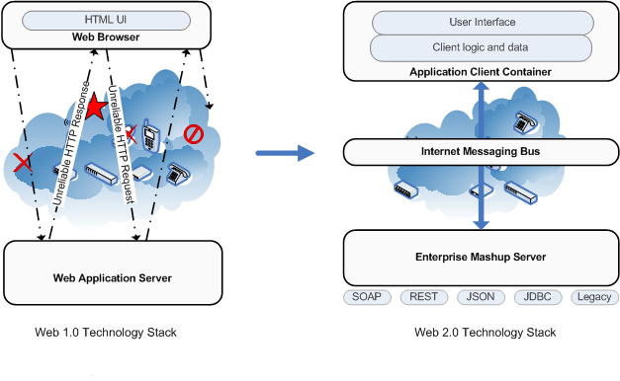
Figure 2. The Evolution of Technology Stack (from Web 1.0 to Web 2.0; source www.coachwei.com)

From Browser to Application Client Container
“Application Client Container” is the client engine for Web 2.0 applications. Many of the Ajax toolkits available today are early example of such client engines. Application Client Container (ACC) is the following:
- ACC is stateful. A web browser is designed to be stateless – it discards all the current state information when a new page is loaded. This is the model of “browsing”. Applications are inherently stateful. To support stateful applications on top of the stateless browser engine, developers have to do a lot of hacking to work around the problem. ACC gives applications such support out of box.
- ACC supports asynchronous interactions by default while browsers require careful developer coding to do so;
- ACC can support offline computing while most of Web 1.0 applications are online only.
- ACC supports mobile computing as a first class citizen.
- ACC supports accessibility.
- ACC supports rich user experience.
According to [5] there are 180 JavaScript libraries available today trying to compensate for the wrong client platform for applications. These Ajax toolkits represent the early evolution of Application Client Container. They still have limitations (for example, lack of support for offline computing), but they are leading the way to the next generation client side computing.

From Unreliable HTTP to Internet Messaging Bus
The Internet was initially designed for presenting and sharing hyperlinked documents in the form of Web pages. Therefore, the communication layer is based on the HTTP “Request/Response” model, which adequately serves the purpose of “browsing.” Internet Messaging Bus is an enhanced HTTP communication layer that delivers reliability and two-way communications.
First off, Internet Messaging Bus supports guaranteed message delivery. Without IMB, when a user submits a request to the server, whether this request will actually arrive at the server or not is unpredictable. If there is a network problem (either with the ISP or within the corporate network itself), there is a good chance the request will be lost. However, this is not always a problem for Internet browsing, as the user can always click the link a second and third time if the first URL request is lost. Although this seems like a basic example in very basic terms, it is a serious problem for mission critical enterprise applications. The case and point being, that it is not out of the realm of possibility that a multi-million dollar transaction can be literally be “riding on the line.”
IMB supports guaranteed order of message delivery. Without IMB, if the user submits two requests in a row, there is no guarantee that the first request will arrive at the server before the second request. Again, while this is not necessarily a problem for browsing Web pages, the result of a later request can be dependent on an earlier request when using the Internet for business applications. A random ordering of message delivery makes the application behavior unpredictable — a pattern that many Web application users are familiar with.
IMB supports once and only once message delivery. Without IMB, a user request may arrive on the server side twice or even more, if some network problem caused the message to be cached and delivered more than once. Again, while this is not necessarily a problem for browsing Web pages, it can cause serious transactional problems for business applications.
IMB supports server-initiated communications (server push). HTTP supports client-pull only. In a “client pull only” model, the server works like a phone that never rings. Obviously this is not a problem for browsing because the server needs to simply respond to page requests. However, many enterprise applications require the server to initiate interactions. For example, a stock trading application needs to push the latest stock price to the end user from the server. To side step this problem, developers typically use “client polling,” but this significantly increases the server/network load and therefore decreases application performance.

From Application Server to Mashup Server: Next Generation Middleware
The evolution on the server side is the emergence of a new category of middleware called “Enterprise Mashup Server”.
Application Server is the middleware component in a Web 1.0 stack. An “Enterprise Mashup Server” is not a replacement for an application server, but instead, an additional component to dramatically simplify the development and maintenance of composite applications. An enterprise mashup server enables three tasks:
- Data integration
- Service/business process integration (logic integration)
- UI integration
“Mashup” as a term was created in the consumer space to describe the kind of applications like “HousingMaps”. As a consumer application, “HousingMaps” requires only UI integration. For business applications, it is highly likely there will be need to achieve integration at data tier or middle tier. In particular, the adoption of SOA creates a natural service repository for service/business integration for mashup applications.

Compatibility with Web 1.0 Is Key
The rising Web 2.0 technology stack is not replacing the Web 1.0 stack. Instead, compatibility with Web 1.0 is a key requirement.
On the client side, application client container is not replacing browser. Browsers serve the purpose of web browsing well. Application client containers may be implemented by leveraging available means from web browsers and are likely to run inside web browsers. Some of the Ajax Engines, such as Apache XAP [6], are early examples of such client containers.
Internet Messaging Bus is not a replacement for HTTP either. Instead, IMB relies on HTTP and is built on top of HTTP.
Mashup Server does not replace application server either. Application server functionalities are just as important for Web 2.0 application as Web 1.0 ones. Enterprise Mashup Servers typically run inside an application server, thus enabling developers to leverage all the Web 1.0 capabilities.

3.0 Examples of Market Offerings

Here are a few examples of the offerings in the enterprise mashup server market space. We are not trying to generate a comprehensive vendor list, this market is hot, more and more players are joining it and there is also a certain degree of overlap between vendors of pure mashups technologies and similar ones dealing with Rich Internet Applications, AJAX Service Bus, Internet Service Bus (ISB) and Enterprise Service Bus, other types of SOA and SOBA based applications. For the purposes of this review we list products from Kapow and JackBe. Good example of similar platform based on ISB would be Nexaweb (http://www.nexaweb.com)

Kapow Mashup Server
The Kapow Mashup Server (http://www.kapowtech.com) is composed of three functional modules that are designed to be used either as standalone components, or in combination with one another in a fully integrated fashion.
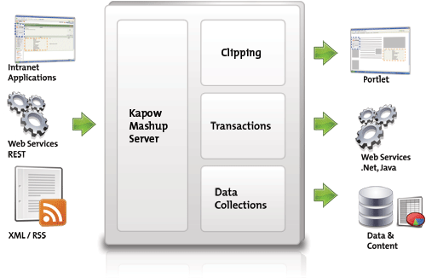
Figure 3. Structure of Kapow Mashup Server
• Clipping Module: targeted at integrating the presentation layer of multiple web applications, allows existing Web interfaces to be reused as portlets in enterprise portal systems. This module contains out-of-the-box point-and-clip support for creating portlets for leading portal products.
• Transaction Module: Creates Web Service interfaces (REST or SOAP) for Web-based applications and business logic that are not yet service-oriented, or uses existing web services where they exist. This provides a unique capability for the development of composite applications that are a mixture of legacy and service-oriented components.
• Data Module: Integration from Web-based data and content sources into databases and CMS systems. Data from any Web site can be inserted into, and synchronized with, the most database systems.
Regardless of which Kapow Mashup Server modules are used, all server solutions include a visual design environment that uses an intuitive “point and click” interface for rapid mashup creation. The server also supports clustering for high-performance or high-reliability applications and includes a full featured management module for enterprise class deployments.

Presto
The Presto Rich Internet Applications (REA) platform from JackBe (http://www.jackbe.com/Products/presto.php)seamlessly combines Ajax-based Web applications with SOA services, middleware and data. The Presto platform is loosely-coupled and thus easily integrates with existing data assets. Presto REAs deliver best-in-class reliability and scalability, and support distributed business units that require custom governance administered by IT.
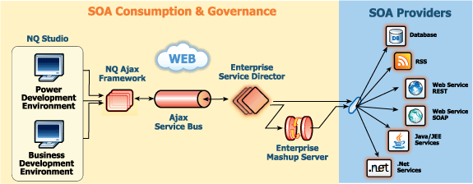

Figure 4. Architecture of JackBe Presto REA Platform

Presto Product Components
NQ Studio:
NQ Studio is a complete development and runtime environment to rapidly create sophisticated Rich Enterprise Applications. It offers a unique approach to design, development and delivery for both power developers and business analysts, and provides two NQ Studio development environments tailored to the specific needs of both power developers and business analysts.
Presto Enterprise Mashup Server
The Presto Enterprise Mashup Server (EMS) provides the foundation to optimize business activities by empowering users to mashup existing services and data into new and customized activities and views.
The EMS is built to integrate with standards-based services and therefore does not require proprietary features, so it can be used easily and flexibly with any existing enterprise SOA services and applications. Furthermore, because all of the application composition occurs on the server rather than delegating this responsibility to the browser, enterprises can be certain that the end-result is secure and governed.
Presto Enterprise Service Director
Enterprises must ensure that proper governance is maintained when services and data are consumed by applications. The Enterprise Service Director provides service access authentication, authorization, and governance. All governed SOA services are made available at development and runtime based on IT-controlled governance policies.
Presto Ajax Service Bus
Unlike most consumer-focused RIA applications, enterprises require robustness and reliability when communicating between the browser and SOA data services. The ASB consists of a series of innovations built on top of the standard XMLHttpRequest to provide security, reliability, once-and-only-once delivery semantics and true “push” events from within the browser. The ASB requires no installation and automatically handles dropped and spotty network connections.
With high numbers of user connections and high volumes of notifications, the ASB can be deployed in a cluster to enhance scalability, throughput, and availability. The ASB has been designed to work in a distributed, fault-tolerant environment under heavy load while ensuring a high level of interactivity and responsiveness for system users.

4.0 Conclusion
In this paper we had performed an overview of the Enterprise Mashup concept and underlying technology stack, which consists of the Application Client Container, Internet Messaging Bus and Enterprise Mashup Server. We had seen that mashups can exist anywhere on the Web, either primarily on the server or entirely on the client side and currently there are 5 different style mashups: Presentation, Client-Side Software, Client-Side Data, Server-Side Data and Server-Side Software ones. While the overall concept, especially at the enterprise level is still evolving together with the base technologies and standards, there are multiple product offering available on the market which allow to design and implement robust a scalable Enterprise Web 2.0 applications.

References
1. Jason Bloomberg Mashups and SOBAs: Which is the Tail and Which is the Dog?
http://www.zapthink.com/report.html?id=ZAPFLASH-2006320
2. Dion Hinchcliffe Is IBM making enterprise mashups respectable? http://blogs.zdnet.com/Hinchcliffe/?p=49
3. http://www.mturk.com/mturk/welcome
4. http://www-03.ibm.com/press/us/en/pressrelease/19821.wss
5. Web 2.0 Re-examined http://www.coachwei.com/blog/_archives/2006/12/7/2556751.html
6. http://incubator.apache.org/xap/

